ECEN 350 – Equation Sheet 2 (12/27/2024)

**Good coupling: XC < 0.1R,** where R is the equivalent input or output resistance, with $X_{C}=1/{2πfC}.$

**Good bypassing: XC < 0.1R,** where R is the equivalent resistance of the parallel element to short out for ac signals.

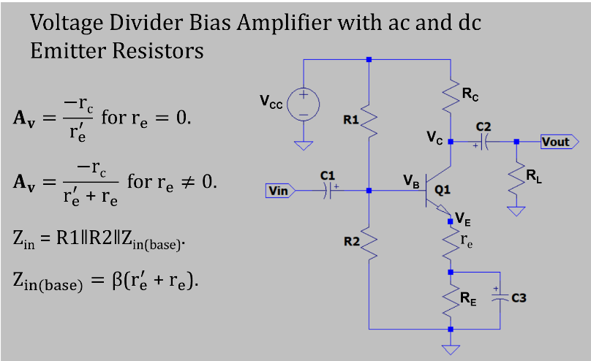

CMOS Dynamic Power Dissipation: $P_{Dynamic}=C_{Load}N_{SW}V_{DD}^{2}f, where V_{DD} is the supply$

Voltage, NSW is the number of nodes switching and f is the switching frequency.

$$Sizing CMOS Digital Logic: W_{p}=\frac{μ_{n}}{μ_{p}}W_{n}, where μ is mobility, W_{n} is the relative width of$$

the n-channel transistor and Wp is the relative width of the p-channel transistor.